* **Exercises from chapter 08 Introduction to Transactions**
* Questions
* 1. Analyze the ACID properties of transactions.
* 2. Draw the state diagram of a transactional and analyze each of them. Which is the difference between partially committed and committed?
* 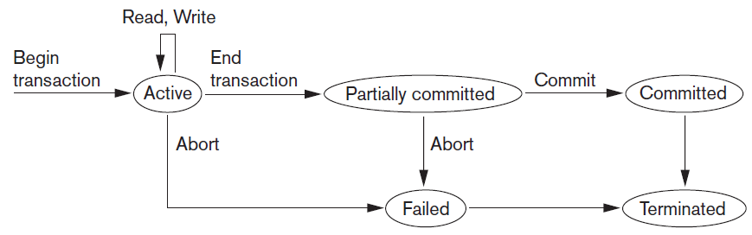

3. What is understood by concurrent execution of transactions in databases in a multi-user environment?

Analyze why concurrency control is needed and provide some exemples.

4. What is the log file used for?

5. Explain what problems can arise when there is concurrent access to data and explain each one.

6. Relate each section with the corresponding concept (one of them is related to two).

|  |  |
| --- | --- |
| The system log |  |
| single-user DBMS |  |
| Mutiprogramming |  |
| Granularity |  |
| Transaction |  |
| DBMS multi-user |  |
| Begin and end states of a transaction |  |
| Transaction Processing systems |  |

1. At most a single user can use the system at a time
2. It forms a logical unit of processing
3. Specify the transaction boundaries
4. Allows the operating system to run multiple processes concurrently
5. Several users can access the database concurrently
6. Systems with large databases and hundreds of concurrent users
7. Require high availability and fast response time
8. Size of the elements stored in the database
9. Keeps track of all operations carried out by transactions.

7. Given the following transaction plans, indicate which operations are in conflict and what operations are not (give two examples). Justify your answer.

|  |  |
| --- | --- |
| Operation | abbreviation |
| Read element | r |
| Write element | w |
| Commit | c |
| Rollback | r |

P1= r1(x); r2(x); w1(x); r1(x); w2(x); c2; w1(y); c1;

P2= r1(x); w1(x); r2(x); w2(x); c2; r1(y); c1;